PILGRIMAGE TOUR- VARANASI & AYODHYA
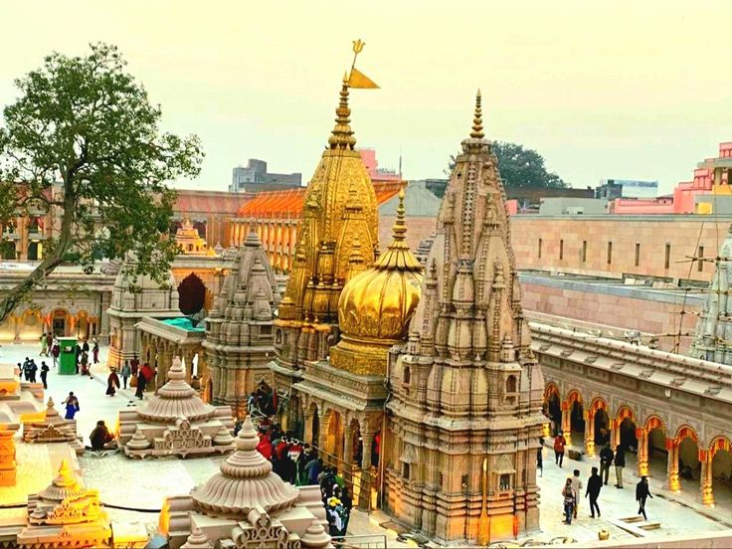

Circuit: Ayodhya – Varanasi

ITINERARY PUBLISHED:
DAY 01: | 31 MAY’26 | DELHI – AYODHYA (VANDE BHARAT EXPRESS – 06:10HRS / 14:30HRS)
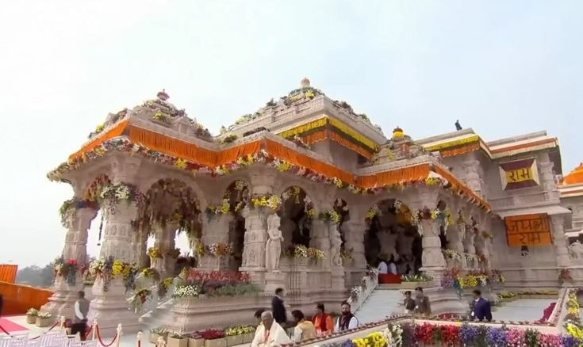
Meeting and assistance upon arrival at Ayodhya Cantt railway station and transfer to the hotel. Upon arrival, check in at hotel in Ayodhya.

Evening at 1730Hrs proceed to visit Ram Ki Paidi witness the beautiful Surya Aarti ceremony followed by by walk through the ghats and temple surroundings of Ayodhya. Later at 2000Hrs proceed for VIP Darshan at Ram Mandir with guide.

Overnight stay at hotel in Ayodhya

DAY 02: | 01 JUN’26 | AYODHYA – VARANASI (218KMS, 04HRS DRIVE)
Early morning at 0700Hrs proceed for VIP Darshan at Shri Ram Janmabhoomi Temple. Later continue sightseeing covering Hanuman Garhi, Kanak Bhawan and Dashrath Mahal. Return to hotel for breakfast and check-out. Depart for Varanasi at 09:00 AM by private vehicle. Upon arrival in Varanasi, check-in at hotel. In the evening enjoy a private boat ride on River Ganges and witness the beautiful Ganga Aarti ceremony from the private boat itself.

Overnight stay in Varanasi.

DAY 03: | 02 JUN’26 | VARANASI
At 05:00 AM proceed for Shri Kashi Vishwanath Temple darshan with local guide assistance for smooth temple access and darshan process. After darshan return to hotel for breakfast and relaxation. Remaining day free for leisure or optional local exploration

Overnight stay in Varanasi.

DAY 04: | 03 JUN’26 | VARANASI
Full day free for relaxation / eplore surrounding.

Overnight stay in Varanasi.
DAY 05: | 04 JUN’26 | DEPART VARANASI BY POORVA EXPRESS AT 1855HRS
Morning at Leisure. Evening on time drop at Varanasi Junction to board train for Delhi.
TOUR COST
CATEGORY | COST PER PERSON
Cost 12 paying pax | INR
Single Room Supplement | INR

City | Hotel | Date | Night
Ayodhya | Padamshree Palace or similar | 31 May – 01 Jun’26 | 01 Night
Varanasi | Palace On Ganges or similar | 01 – 04 Jun’26 | 03 Night
Total, number of nights |  |  | 04 Nights

Our prices include:

Price per person in a Double / Triple room.

Bed & breakfast at all places.

Arrival / departure transfers, sightseeing tour excursion by air-conditioned Maharaja Seat Tempo Traveler

English speaking guide on 31 May, 01 Jun, & 02 Jun’26

Private darshan at Ram Mandir on 31 May’26

Aarti at Ram Mandir in Ayodhya

Private boat in Varanasi

Early Morning visit to Kashi Vishwanath Temple for VIP darshan

01 night in Ayodhya with bed & breakfast basis.

03 night in Varanasi with bed & breakfast basis.

Government tax (5%).

Our prices do not include:

Beverages.

Any services not mentioned as included, including personal extras such as telephone calls, laundry service, etc

Transportation in Delhi

Accomodation in Rishikesh

Delhi accomodation.

Entry visa. Visas can be obtained online at: www.indianvisaonline.gov.in

Tips for guides (at the client's discretion).

Travel and cancellation insurance (optional).

